Website Name: ClassCompass
Group: Jennifer Kearney, Angelina Lin, Anoua Carrie

User Persona 1: A college professor
Name: Rachel Peterson
Age: 42
Occupation: Associate Professor of Computer Science
Courses Taught: Introduction to Computer Science, Database Systems
Students per Class: 150 (large lectures)
Tech Comfort Level: Moderate

Goals:
- Quickly identify students who are struggling
- View class-wide learning patterns
- Save time on grading analysis and progress reporting
- Personalize feedback for students
- Compare performance across sections or semesters

Pain Points:
- LMS dashboards are very limited
- Hard to track 100+ students manually
- Wants early warning signals for struggling students
- Data scattered across current tools
- Time consuming end of semester reporting

Motivations:
- Wants to support student success proactively
- Values tools that save time and reduce admin burdens
- Appreciates clear, visual dashboards
- Believes data should enhance teaching, not replace it

User Persona 2: A college professor
Name: Bobby Bobman
Age: 67
Occupation: Mathematics professor
Courses Taught: Calculus I, Multivariable Calculus,
Students per Class: 150 (large lectures)
Tech Comfort Level: Moderate

Goals:
- Understand students’ learning style to adapt his teaching methods
- Be more efficient when it comes to grading with curves (because many students fails his class)
- Use predictive analytics to warn students early when their performance drops
- Improve student comprehension and overall course outcomes

Pain Points:
- Has a TERRIBLE Ratemyprofessors (teaches too fast, exams are nothing related to lecture, etc.)
- Half of his class always fails or withdraws and he doesn’t know why
- Lacks tools to visualize where students begin struggling (which topics)
- Feels overwhelmed managing data across multiple large classes and sections

Motivations:
- Genuinely wants to improve student understanding and teaching effectiveness
- Wants student feedback in real time
- Hope to rebuild his reputation before he retires

Potential Personas (if we have time)

User Persona 3: A college student
Name: Miranda Smith
Age: 20

Goals:
- Track personal grades in one place
- Predict semester GPA and grades to see which courses to prioritize
- Understand which topics in a course was the hardest
- Get visualizations of improvements over time (we hope)
- Give feedbacks to professors so she could be heard

Pain Points:
- Hardworking student and always wants to know how much she needs to get an A for a class
- Manual GPA calculations are time-consuming and prone to mistakes
- Too many platforms where her grades are located it’s hard to keep track of
- Feels like her opinions and feedbacks were never heard
- Likes to give constructive criticism
- Is a visual learner, and needs graph to truly understand how she’s doing in a class

Motivations:
- Wants more control and visibility over academic progress
- Appreciates when data translates into actionable feedback
- Wants to be able to track her performance so she knows her weaknesses and can work on it

User Persona 4: A parent of a college student
Name: Jake Deere
Age: 50
Occupation: Lawyer

Goals:
- Stay informed about his child’s academic performance and progress without constantly emailing teachers
- Identify early if his child is struggling in a subject so he can arrange tutoring or extra help
- View class averages and attendance patterns to understand how his child compares to peers
- Receive concise, visual reports that summarize grades, trends, and teacher feedback
- Encourage his child to take responsibility for their own learning and improvement

Pain Points:
- School portals provide minimal insights (only show final grades, not why or where performance changes)
- Hard to get timely updates or consistent communication from teachers
- Finds existing systems cluttered and confusing to navigate
- Wants a clearer picture of his child’s strengths and weaknesses to support them effectively
- Often feels left out of the academic loop until report cards come out
- Because of his job as a lawyer, he often doesn’t have time to ask his child where they are struggling and why but still wants to be understanding and helpful despite his busy schedule

Motivations:
- Values education and wants to be an informed, supportive parent without micromanaging
- Appreciates clear, visual data summaries that save time and reduce confusion
- Believes that understanding patterns (attendance, topic difficulty, test performance) can help him guide his child
- Motivated by seeing steady academic growth and helping his child stay confident and proactive
- Wants tools that make parent–teacher communication more meaningful and focused

Balsamiq

Home Page / Dashboard
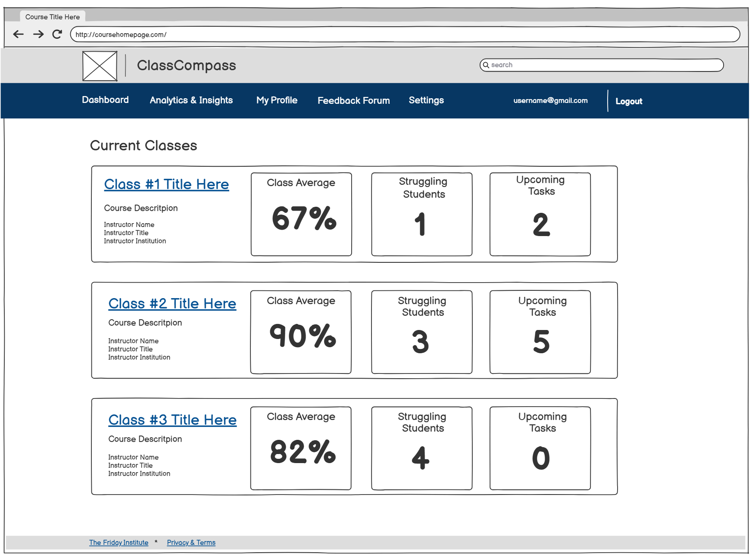

Class Overview Page
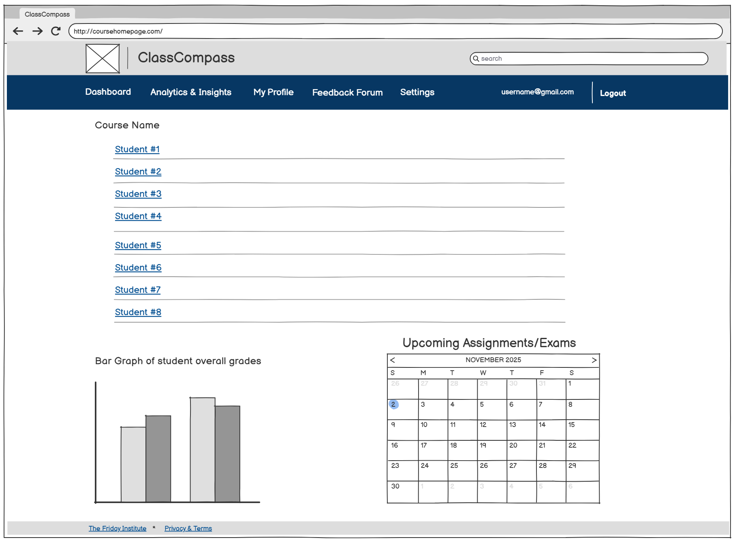

Student Profile Page
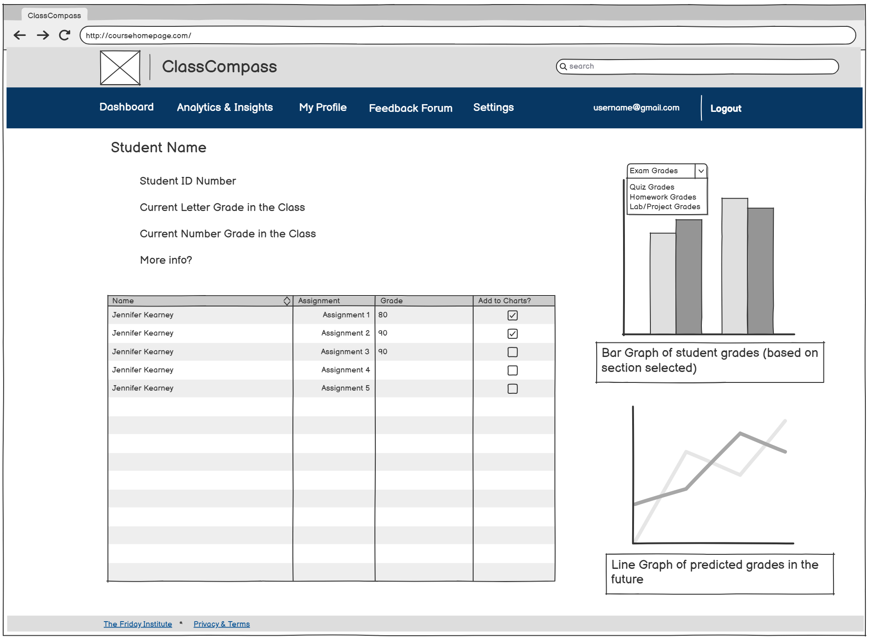

My Profile Page
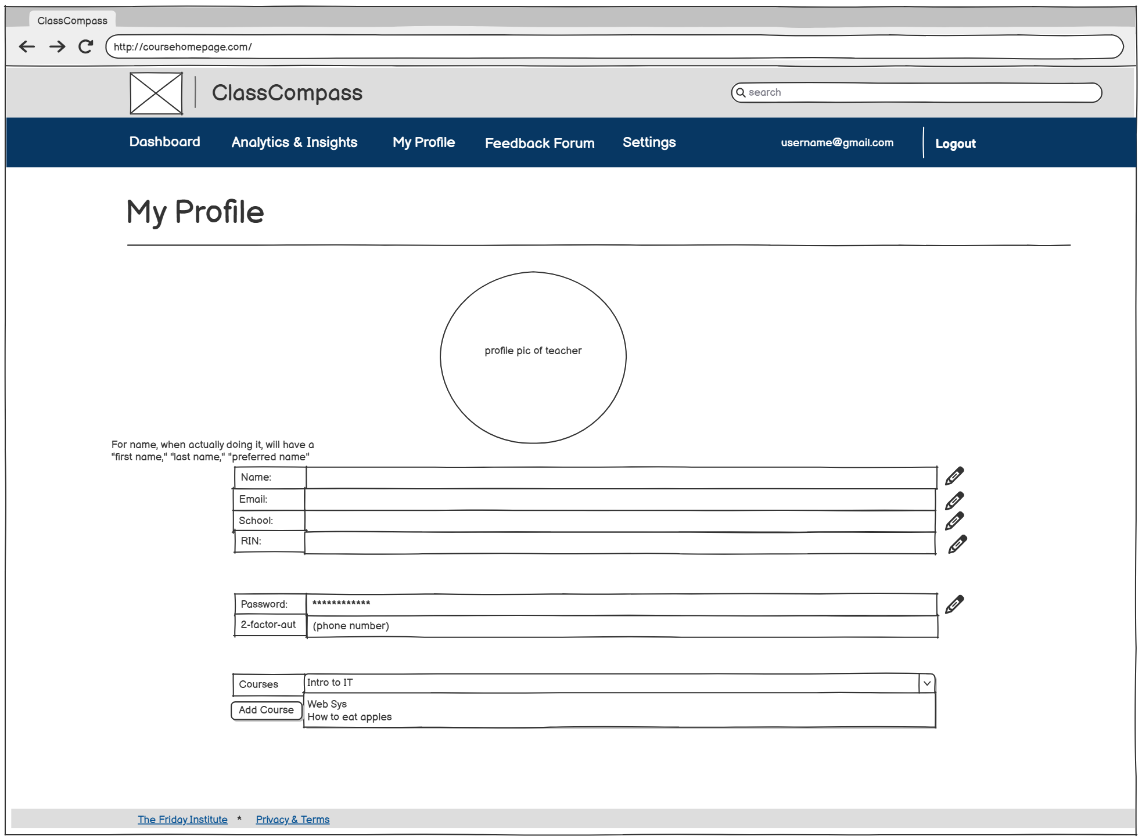

Feedback Forum Page
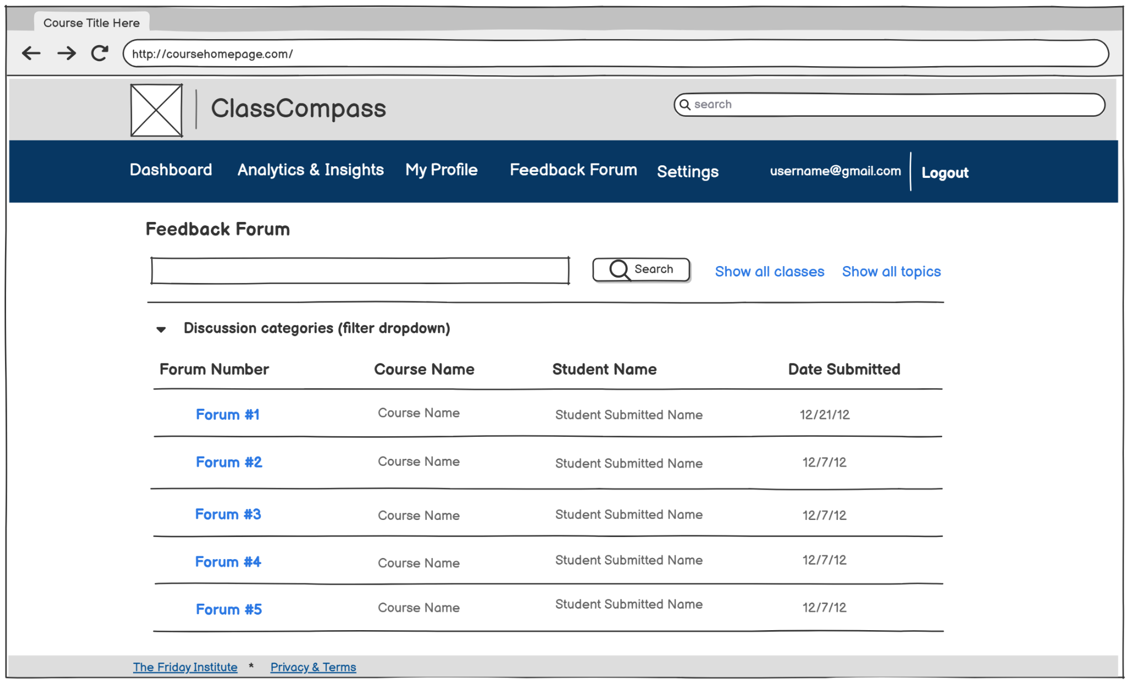

Settings Page
